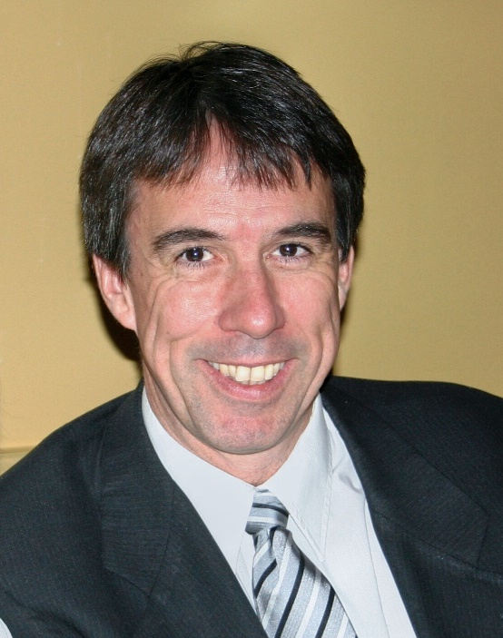
Chris McLindon has been employed as an exploration geologist in the oil and gas industry since 1980. He received a B.S. in Geology from L.S.U. in 1979. Chris has worked for several companies in the New Orleans area, as well as being self-employed for several years. Chris is currently employed by Upstream Exploration, LLC in Metairie, LA. He is currently the president of the New Orleans Geological Society, and a member of the American Association of Petroleum Geologists, the Geological Society of America, the American Geophysical Union, and the Society of Independent Earth Science Professionals.
Since 2015 Chris has coordinated the NOGS Fault Atlas research initiative based on providing oil and gas industry knowledge base and seismic data for graduate-level university research on the relationships between near-surface geology, subsidence, and coastal processes. There are currently seven research projects underway at UNO, Tulane and ULL as a result of this initiative.

